1. Three class with priors are respectively P(L=1)=0.15,P(L=2)=0.35,P(L=3)=0.5.

The data distribution are as follows



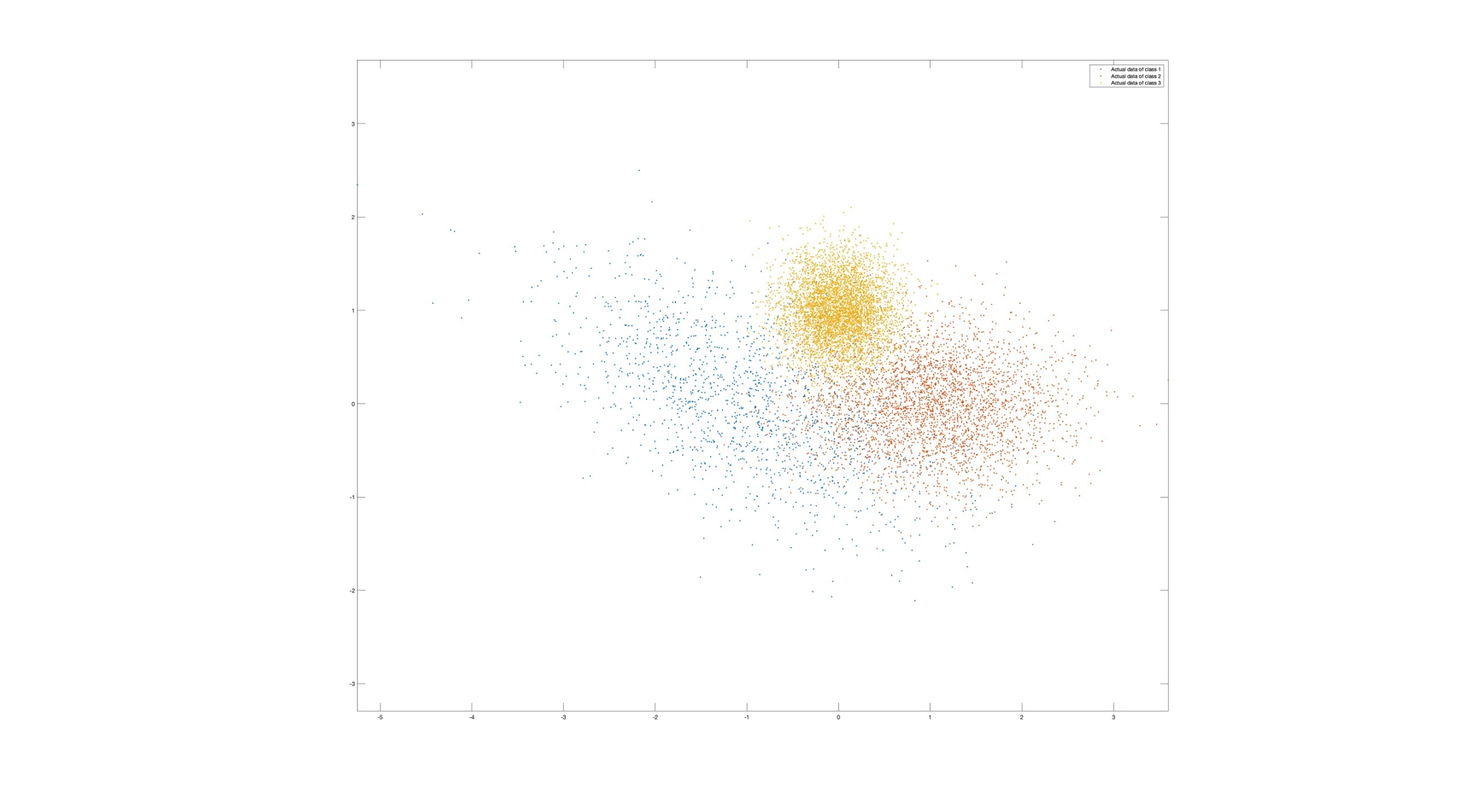

The plot shows the true data of each three classes

Receive the discriminant score for the function of the evalGaussian. Which indicate the decision as P(wi|x) is the largest of three class. Then make the decision for the data by choosing the largest discriminant score.

The confusion matrix result is as follow

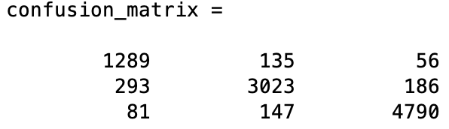

Case, decision = 1, L = 1 has 1289 samples

Case, decision = 2, L = 2 has 3023 samples

Case, decision = 3, L = 3 has 4790 samples

These are the correct decisions.

Case, decision = 2, L = 1 has 135 samples. Case decision = 3, L = 1 has 56 samples.

Case, decision = 1, L = 2 has 293 samples. Case decision = 3, L = 2 has 186 samples.

Case, decision = 1, L = 3 has 81 samples. Case decision = 2, L = 3 has 147 samples.

Confusion matrix shows the number of samples correct and incorrect. Where column indicate to decision class and the row indicate to actual class.

Total number of miss equal to (10000-total correct) = 10000-9102 = 898.

Thus, the error can be calculated by 898/10000 = 0.0898 = 8.98%

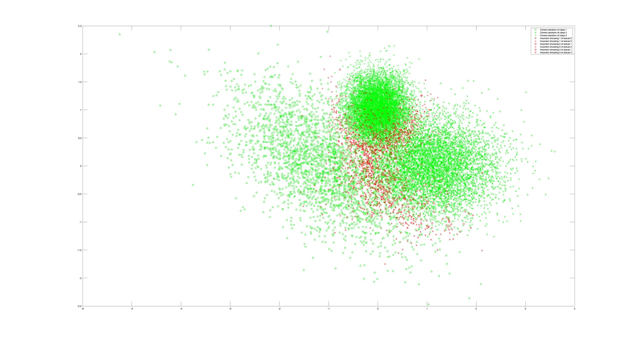

The plot shows every samples with shape and color indicate for the correct decision and the wrong decision.

1. An true point is locate by land marks by measurement r1 = dT + n. Where n is the noise, and each noise is independent to each other in each K measurement. The objective function to determine the estimation is as follow.

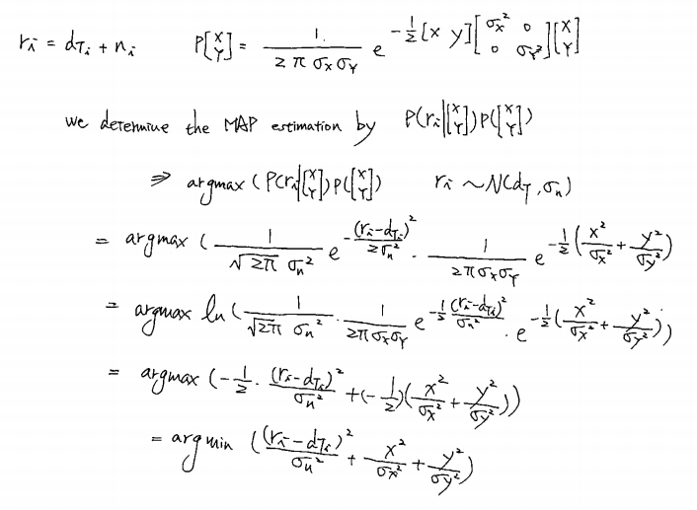

Here the minimum of the function determine the most possible of the point

By the function create the estimate point from -2 to 2 both on the plot and generate the contour

Take the sigma_noise as 0.3, sigma_x and sigma_y = 0.25; true point (0.9,0.9)

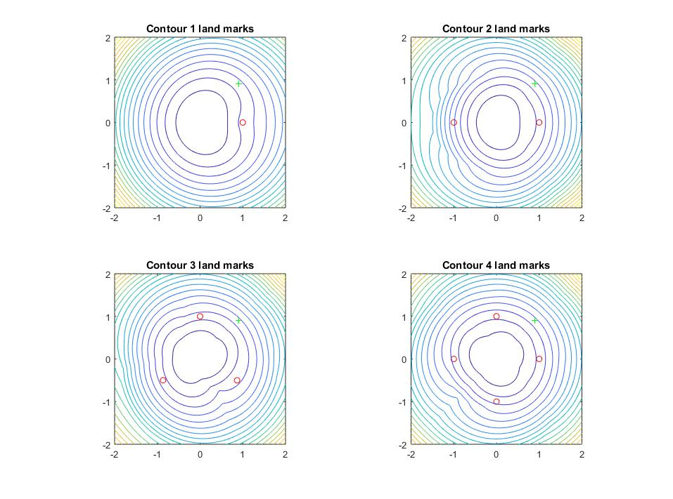

The plot show that the contour for different land marks. Since the objective function of the prior domain the determination of the result. However, different land marks leads to the different result. I consider the more land marks will estimate more correctly because the contour center seems moving to the true point when the land mark number increase.

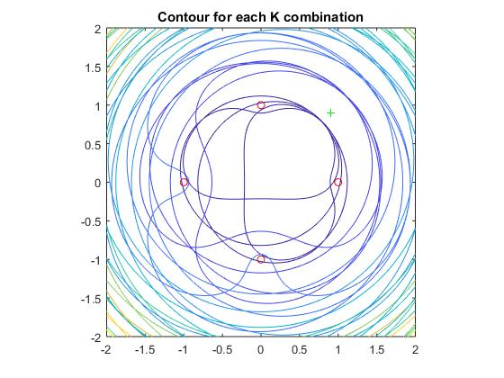This plot shows the different contour combination of different land marks by each estimation.

Since each noise is independent to each other. Same color contour have the rage on it. This range can be seen as normal distribution mean value at dT and Sigma_noise = 0.3.

1. The estimation function could be find as the following processing

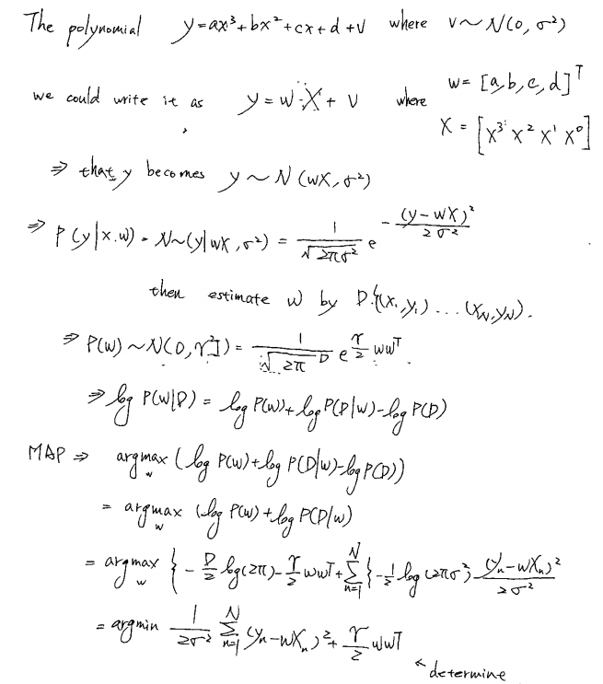

Since we have the estimation function, we could estimate the w on matlab